DIS-US-Buffalo Effigy

hard stone effigy of a buffalo and it is a buffalo standing, so amazing was the artistic ability of ancient Native Americans, I found this in Rockcastle Co., Ky. in 2010, just a beautiful artifact and a treasure, this is of museum quality. the measurements are of: the buffalo ; 4" wide 2 1/8 tall by 1" thick. IT IS VERY RARE and guaranteed authentic for life, I found this while surface hunting on my own private property in South Eastern Kentucky., no caves, graves or any sacred sites disturbed.

# Order details

## Sales order

Sold by [barba-locka](http://myworld.ebay.com/barba-locka) ( [72](http://feedback.ebay.com/ws/eBayISAPI.dll?ViewFeedback&userid=barba-locka) )

### Delivery package 1 of 1

Delivered on Wednesday, Apr 6, 2016

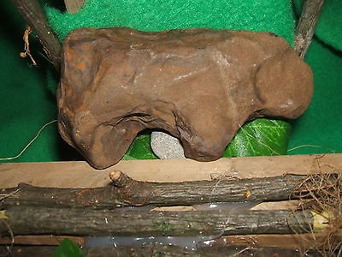

#### [,AUTHENTIC BUFFALO EFFIGY](http://www.ebay.com/itm/301915303447)

|  |  |
| --- | --- |
| Item price | $53.00 |
| Quantity | 1 |
| Item number | 301915303447 |
| Shipping service | USPS Priority Mail Medium Flat Rate Box |